CECS 225

Lab 5

Eugene Paul Mesina



* **Section 1:** RegFile

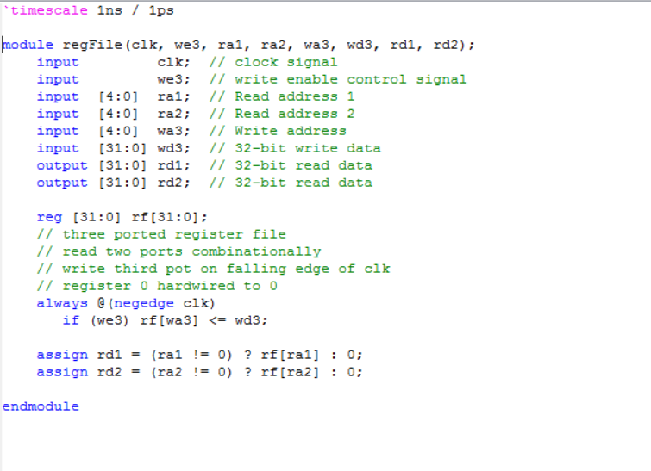

* **Section 2:** RegFile Tester
* 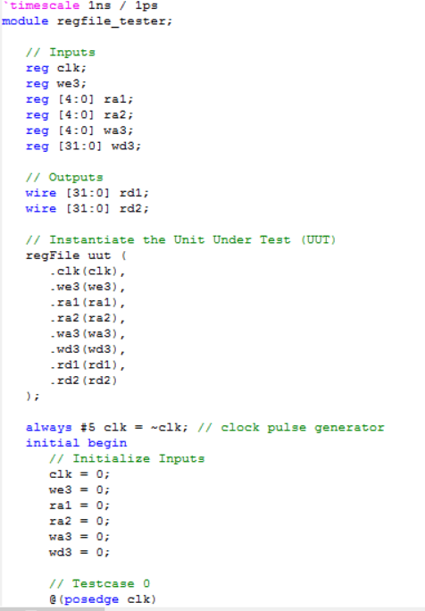

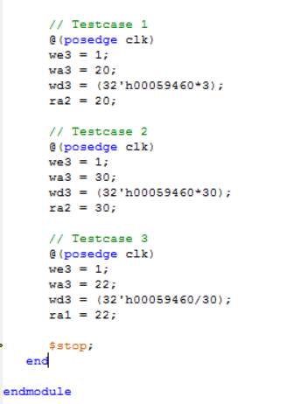

* **Section 3:** Simulation WaveForm

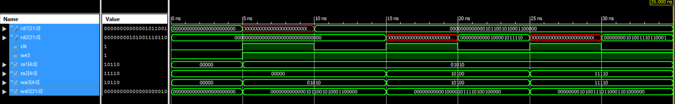

* **Section 4:** RTL regFile

